**PROJECT DOCUMENT**

**Abax Academy EDUCATIONAL INSTITUTE**



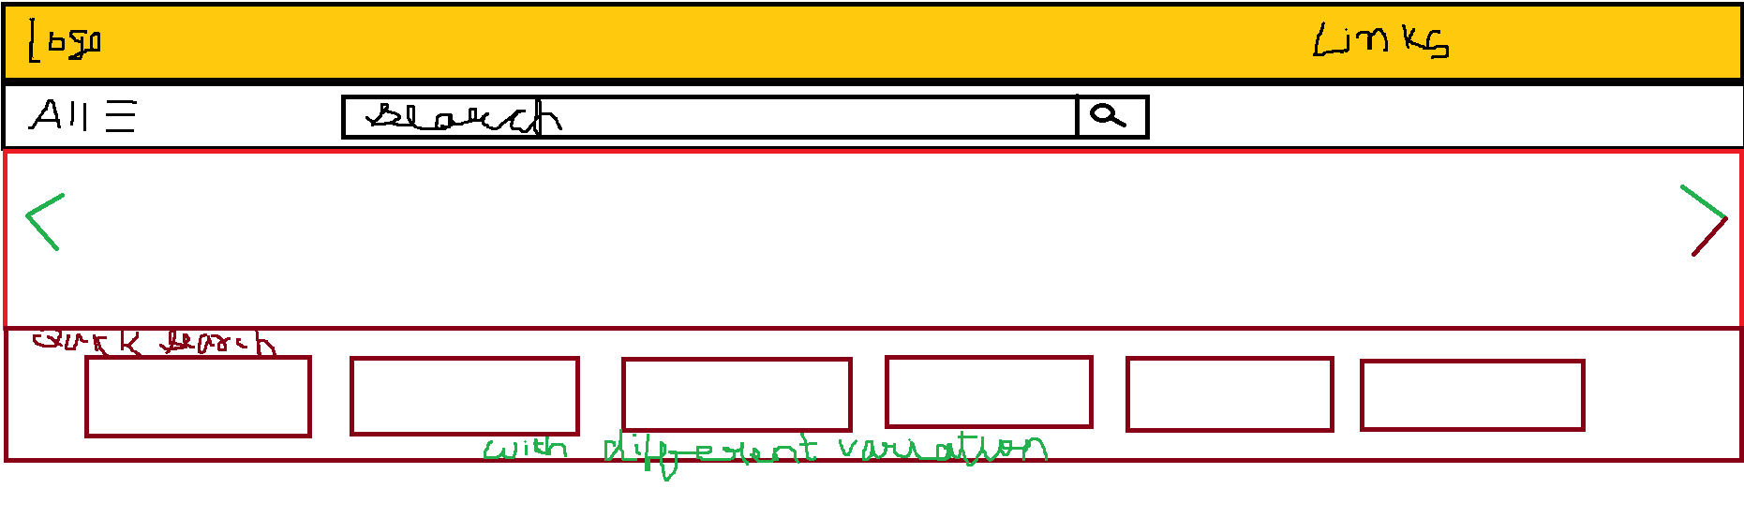

**OVERVIEW**

**This is the big project which is based on online education system. It has**

* **Home Page**
* **Listing Page**
* **Registration form**
* **Login form**
* **Book seller registration**
* **Help and support**
* **Course details card**
* **Offer details**
* **Footer part containing About Us, Help , Links, copyright.**